**Sample Picture Series Prompt With Accompanying Questions**

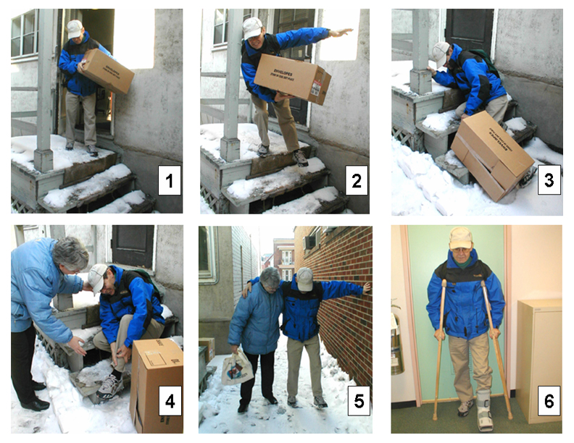

**Questions That Tap Grammar**

**Present progressive**

* What’s going on in each of these pictures?

**Present simple**

* Where do you think this scene takes place?
* Who do you think these people are?
* What precautions do you take when it’s snowy?
* They say that most accidents take place on Mondays. Why do you think that this is so?
* What kinds of jobs are the most dangerous? What specifically makes them dangerous?
* What are the dangers associated with living in a very hot climate?

**Past**

* What do you think happened between picture 5 and picture 6?
* Have you ever broken any bones? What happened?

**Future**

* What do you think the man’s condition will be in one week? In one month? In six months?
* How will you prepare for this coming winter/summer? (clothes, house, car)

**Modals**

* What do you think might be in the box?
* What precautions should the man have taken?
* What should people do when they see an accident?

**Conditional**

* How could this accident have been avoided?
* What would have happened if he hadn’t been carrying anything? If he had been carrying something heavier?
* What could have happened to the man that would have been more serious?
* What would the woman have done if it had been night-time and she didn’t know the man?
* How would this story be different if the man had been alone?
* How would your life be different if there were no winter season?

**Questions That Tap Functions**

* **Description**: Describe the scene in picture 4
* **Narration**: (1) Tell me the story the pictures show. (2) Tell me about a specific time when you had difficultyduring the winter. (3) Tell me about a specific time when you helped someonein need (or when someone helped you).
* **Explanation**: Why did this accident happen?
* **Opinion**: Whose fault is this accident (the man’s, the landlord’s)? Explain.
* **Comparison**: (1) Compare your activities in the winter and the summer. (2) Compare working outdoors with office jobs.
* **Hypothesizing**: Where could this man be going?
* **Defending a position**: In some cities, homeowners are responsible for clearing the snow on the sidewalks in front of their homes; in other places, the city does it. Whose responsibility should it be? Why?

**Role-Plays**

* **Giving advice:** (1) The man is your friend. Give him some advice about how to recover quickly. (2) Your friend is moving to Canada from a warm country. Give her advice about living here.
* **Expressing needs:** You are the man. Your office is on the 3rd floor of a building with no elevator. Explain to your office supervisor what special arrangements you may need while you are on crutches.
* **Making a complaint:** You are the man. Complain to your landlord about snow removal.
* **Apologizing:** You are the landlord. Apologize to the man for not getting the snow cleared.
* **Reprimanding:** You are the landlord. Talk with your employee who was supposed to have shoveled the snow.
* **Offering to help:** You are the woman. Offer to help the man. Ask about his condition and needs.
* **Explaining:** You are the man. You missed an important deadline because of the accident. Explain to your boss why you didn’t get your work done.